I was pleased to know and work with Alexei Nikolaev during my visits to Moscow and work in Tajikistan from the 1970’s to my last visit to Moscow in 2013. Our initial interactions were during meetings of the Working Group for Earthquake Prediction under Area IX of the bilateral US-USSR Exchange in Environmental Protection. Alyosha’s participation in these meetings was especially valuable because of the wide range of his scientific interests and his balanced support for joint work on various laboratory, field and theoretical studies. As part of my work on triggered seismicity at Nurek Reservoir, he took special interest in using an artificial energy source (“air gun”) to search for possible changes in velocity.

He was an energetic and stimulating scientific colleague. I did not always agree with (or understand?) some of his scientific investigations. Some of his ideas about triggered seismicity were questionable and his investigations about turbid media were somewhat “opaque". Even in his more adventurous ideas, however, he presented challenging questions and encouraged exciting discussion.

My strongest memories of Alyosha will be of his personal warmth. When he entered a room, with his deep, resonant voice and wide, warm smile, he carried with him an aura of friendship and camaraderie that had a strong personal impact on me and did much to encourage trust and collaboration in the joint works of our scientific teams.
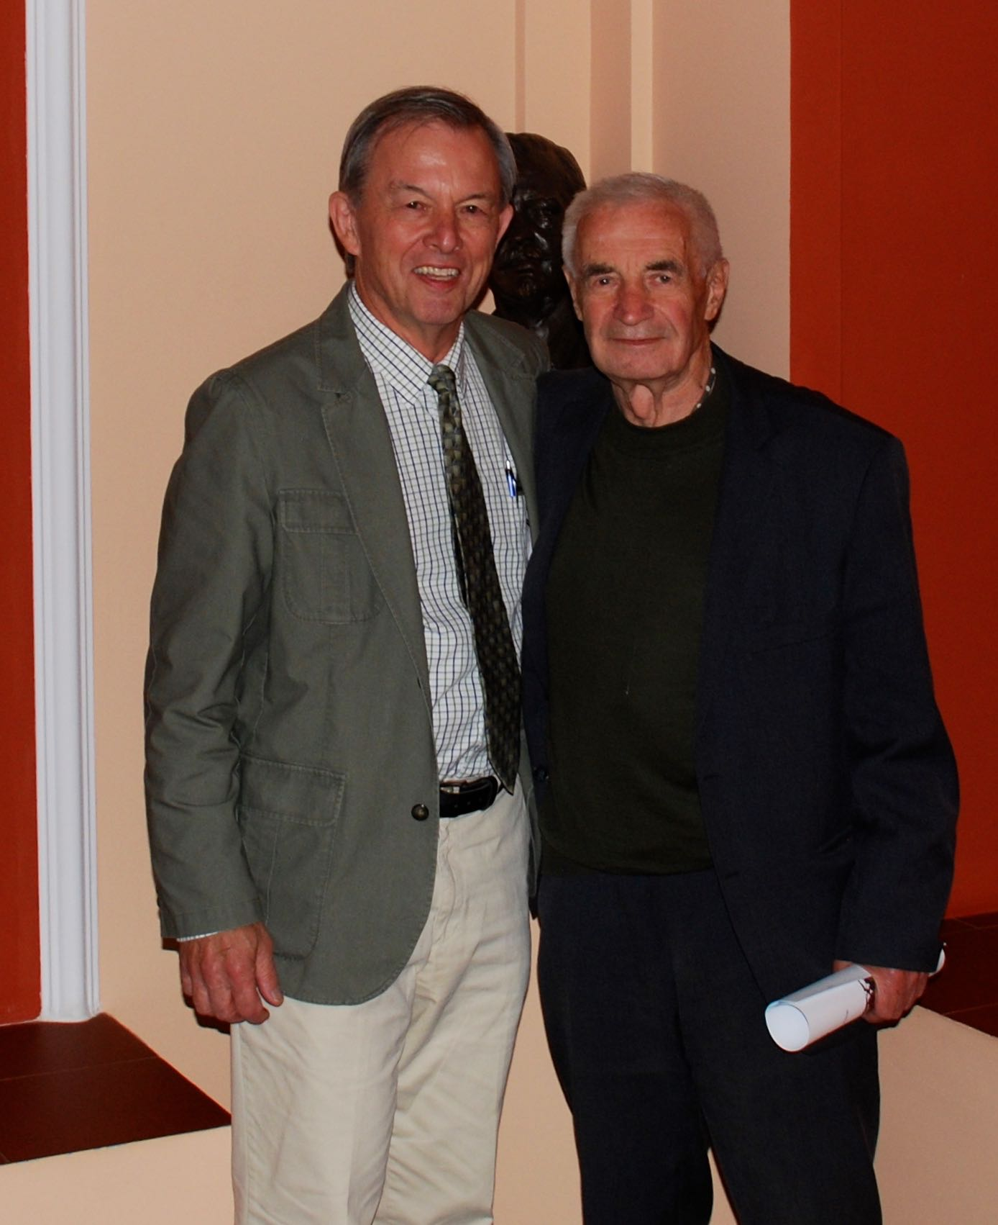
David Simpson, President Emeritus, the IRIS Consortium

